**National University of Computer & Emerging Sciences, Karachi** **Spring 2021**Assignment 03

**Instructions:**

* Read the following scenario carefully before performing the given tasks
* You can use Google if you need to (although it's likely that you won't have to)
* Don't share your solutions with each other
* Use comments to explain your code wherever applicable

**Submission:**

* You'll need to submit a single .***docx*** file containing separate solutions for each task
* Before submission, rename your file as your ID e.g., ***k20-1234.docx***
* **Deadline:** *Sunday, 25th of April, 2021 (07:00 am)*
* To be submitted on Google Classroom *(code:* cj6dvs2*)*

1. For the parallel adder given in the figure below, determine the complete sum by analysis of logical operation of the circuit.

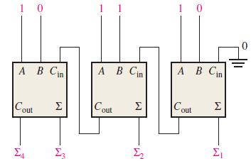

1. Draw the logic diagram of a 1-to-4-line demultiplexer with truth table and logic expression. How can we use decoder for implementation of full adder? Justify you answer by drawing the circuit diagram of full adder using decoder. How can the full adder be implemented using two four-to-one line multiplexer, draw the circuit diagram?
2. In a certain chemical-processing plant, a liquid chemical is used in a manufacturing process. The chemical is stored in three different tanks. A level sensor in each tank produces a HIGH voltage when the level of chemical in the tank drops below a specified point.

Design a logic circuit that monitors the chemical level in each tank and indicates when the level in any two of the tanks drops below the specified point.